
EL64NA(R100)

Features
◆ Onboard Intel Elkhart Lake series processor;
◆ 2 * Intel i226-V network;
◆ 1 * VGA, 1 * HDMI 2.0, TPM2.0 (optional);
◆ 6 * COM, onboard eMMC optional;
◆ DC 12V, 60W;
◆ Size: 120x120 mm

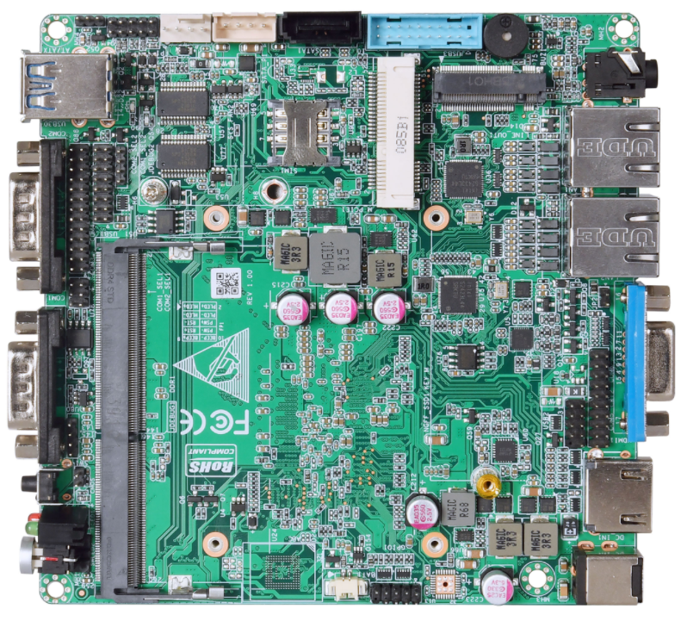

Specifications
Processor | Onboard Intel Elkhart Lake series processor
Processor | EFI BIOS
Memory | 1 * DDR4 SO-DIMM, supports up to 32 GB
Display | 1 * VGA, maximum resolution 1920x1200
Display | 1 * HDMI2.0, maximum resolution 4K@60Hz
Display | HDMI+VGA synchronous or asynchronous display
Storage | 1 * SATA3.0
Storage | 1 * M.2 2280 M-Key (PCIe3.0 2x/SATA3.0, hardware selection)
Storage | Onboard eMMC, 32GB/64GB/128GB optional
Network | 2 * Intel i226-V network (LAN2 optional Intel i211)
Sound card | ALC897
Board edge I/O interface | 1 * VGA, 1 * HDMI
Board edge I/O interface | 2 * USB3.0, 2 * DB9 COM
Board edge I/O interface | 1 * DC JACK, 2 * LAN
On-board expansion  Interface/function | 0-255 seconds, providing watchdog routine
On-board expansion  Interface/function | Aluminum fanless heatsink (the motherboard has a reserved fan interface that supports automatic and manual fan speed adjustment)
On-board expansion  Interface/function | 4 * USB2.0 pin headers, 2 x 5Pin, pitch 2.0mm
On-board expansion  Interface/function | 6 * COM port (COM1/2 is RS232 /RS485 jumper optional, COM3/4/5/6 is RS232)
On-board expansion  Interface/function | 8-bit GPIO, 2 x 5Pin, pitch 2.0mm
On-board expansion  Interface/function | 1 * Mini PCIe (PCIe + USB2.0 protocol)
Power Supply | DC 12V, 60W
Working Environment | Working temperature: -20℃ ~ +60℃;  Working humidity: 0% ~ 90% relative humidity, no condensation
Working Environment | Storage temperature: -40℃ ~ +85℃;  Storage humidity: 0% ~ 90% relative humidity, no condensation
Operating system | Windows10, Windows11, Linux
Size | 120x120mm​​
Weight | 260g including heatsink, 130g without heatsink
EL64NA(R100)

产品尺寸 单位：mm

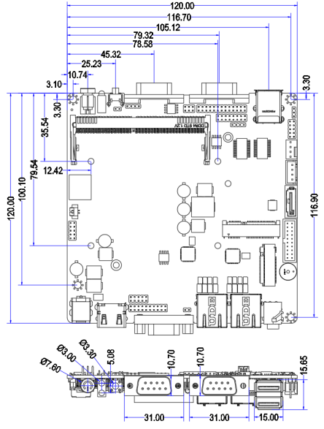

Ordering Information
Model | Options | Descriptions
EL64NA | Onboard Intel Elkhart Lake series processors | J6412/X6413
EL64NA | M.2 2280 | PCIe3.0 X2 and SATA3.0 hardware selection
EL64NA | TPM2.0 | Optional
EL64NA | COM ports optional | 2COM/6COM optional
EL64NA | Onboard eMMC | 32GB/64GB/128GB optional

